Ph 212—Exam 2 Practice -- 2019

Hey Ph 212, Here is a practice exam that we will work on during the Sunday-before-the-exam-practice-session. For those who can’t make it, I did put answers for the long question below. As always, try the problem first before you look at the solutions.

This will is a 55 minute exam. You may use only a non-programmable/non-graphing calculator. As always make sure that you show all of your work in order to maximize your partial credit.
There is a formula sheet available in the front of the room – if you do not use the formula sheet, you receive 3pts of extra-credit. If you do use the formula sheet, please sign the sheet in the front of the room. (You can check out the formula sheet now on the course website.)

Some useful constants:
Speed of light = 3.00·10⁸ m/s G = 6.67·10⁻¹¹ Nm²/kg²
M_{earth}=5.98·10²⁴kg M_{sun}=1.99·10³⁰kg
Radius of Earth = 6.37·10⁶ m Radius of Sun 6.96·10⁸ m
Earth’s mean distance from the sun: 1.50·10¹¹ meters

Some potentially useful Moment’s of Inertia:
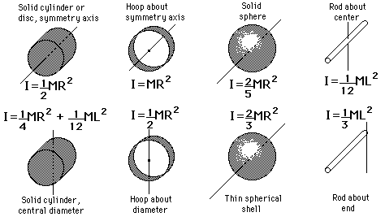
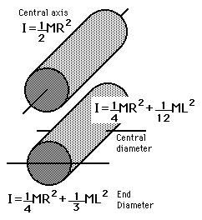

Some formulas that you may need to use:

The Electromagnetic Spectrum
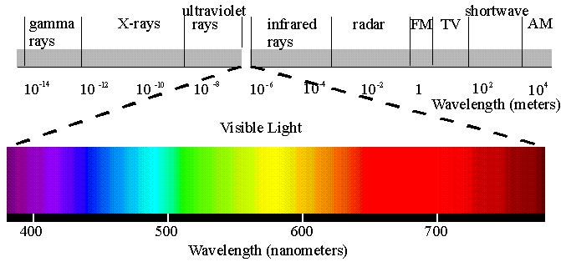

- (2 points) A mass m is on a spring is oscillating with a period T and an amplitude A. If the amplitude is doubled, what happens to the period?

- (2 points) When a weight W is hanging from a light vertical string, the speed of pulses on the string is V. If a second weight W is added without stretching the string, what is the new speed of pulses on this string in terms of V?

- (2 points) The figure below shows a standing wave oscillating at 200 Hz on a string. What is the wave speed?
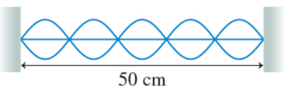

- (4 points)After studying for your physics test, you decide to take a shower. While the warm water washes away your worries, you realize the shower’s length and width are 1.4m.
(a) Draw a picture of what the longest possible wavelength that would create a standing wave in the shower would look like along the length of the shower.

(b) What is the lowest frequency that you could sing at to create a standing wave in both directions of the shower? Assume the speed of sound is $v=350 m/s$in the shower.
10
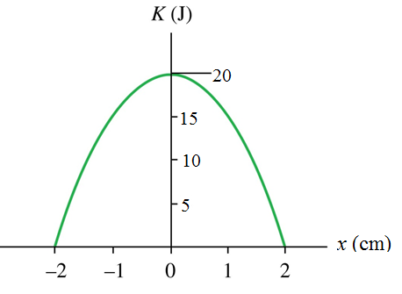
- (2 points) A block oscillates on a horizontal spring. The graph shows the block’s kinetic energy as a function of position. What is the spring constant?

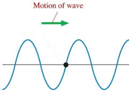
- (2 points) A wave on a string is traveling to the right. At this instant, the velocity of the piece of string marked with a dot is pointing: (circle one)
Up
Down
Zero
Left
Right

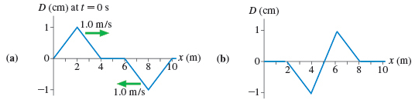
- (2 points) Graph (a) is a snapshot of two traveling waves in a string at t=0s. At what time was time was the snap shot in graph (b) taken?

- (4 points) You wish to write a VPython code to simulate a mass oscillating while hanging from a spring.
(a) Draw a picture, including a FBD of the mass and label all relevant information.

(b) Complete VPython program below that is being written to predict the motion of problem in part a. Assume all necessary code before the while loop has been defined.
m = 0.040 #kg
g=vector(0,-9.8,0) #m/s^2
k= 800 #N/m
While True:
Fnet =
a =
v =
s =

10
9. (10 points) A ruler of mass m = 75g and L=1.0meters is placed so that it is exactly balanced across two spinning cylinders. The coefficient of kinetic friction between the ruler and each cylinder is μ_{k} = 0.2.

You move the ruler 12 cm to the right and discover that it pulls back to the left. It then overshoots the center point, goes a maximum of 11 cm to the left and then continues to move back and forth with smaller and smaller amplitude.

- What is the frequency of oscillation in the ruler?
- What is the maximum distance it goes to the right just after it has gone a maximum of 11 cm to the left?
- Create an equation of motion that describes the motion of the ruler.

After you work on the problem for about 15 minutes, take a look at the online video solution at:
https://www.youtube.com/watch?v=6WveuhJ8brU

10. (10 points) An OSU ocean wave electricity generator is floating on the waves in the open ocean. The peaks of the waves are 50 meters apart and the height of the waves are 10 meters from peak to trough. The waves are moving at a horizontal speed 4m/s.

a. Create an equation of motion that will describe the vertical motion of the float as the waves bobs it up and down.

b. What maximum vertical velocity does the float experience?

c. Draw a “snapshot graph” of the above situation.

d. Draw a “history graph” that describes the motion of the float in the above situation.

After you work on the problem for about 15 minutes, take a look at the online video solution at:
https://www.youtube.com/watch?v=-HHj1XFjBSw&t=6s

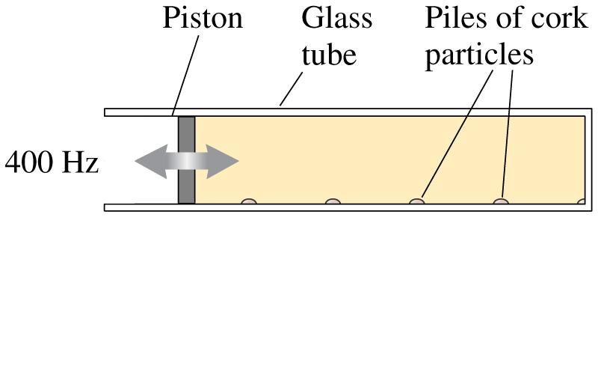
11. (10 points) A long glass tube has a vibrating piston at one end and is closed at the other as shown in the picture. You fill the tube with Sulfur Hexafluoride (SF₆) gas. Very finely ground particles of cork are sprinkled on the bottom of the tube. The speaker is set to emit sound at 400Hz. As the speaker emits its sound, you discover that the cork particles collect in small, regularly spaced piles along the bottom. From the information given in the diagram, what is the speed of sound in SF₆ gas?
67.5cm
4.0cm

After you work on the problem for about 15 minutes, take a look at the online video solution at:
https://www.youtube.com/watch?v=bw2Hx4iYr9Q

1 - 8: As usual, the beginning of the exam will be a collection of conceptual questions. I have created a “Conceptual Question for Practice Part 2” on Mastering Physics. These would be good to practice.

Also, don’t forget to take a look at the thin film video at:
10
Part 1: https://www.youtube.com/watch?v=EdiKRejCyPA
Part 2: https://www.youtube.com/watch?v=M-xYKyI1mN0

