Ph 212 Exam 1 Version A Winter 2010

You have 55 minutes to complete this exam.

Some useful constants:
Speed of light = 3.00·10⁸ m/s
G = 6.67·10⁻¹¹ Nm²/kg²
M_{earth}=5.98·10²⁴kg
M_{sun}=1.99·10³⁰kg
Radius of Earth = 6.37·10⁶ m
Radius of Sun 6.96·10⁸ m
Earth’s mean distance from the sun: 1.50·10¹¹ meters

Some potentially useful Moment’s of Inertia:

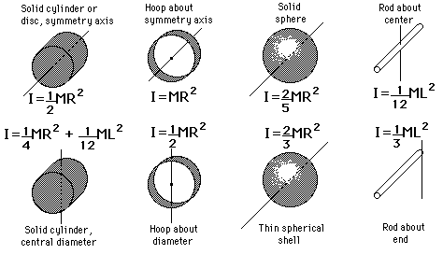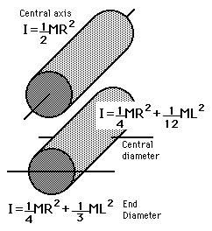

Conceptual Questions:
Remember, even though some of these conceptual questions are multiple choice, remember that you always want to show all you work in order to maximize partial credit.

1. An astronaut is orbiting the Earth in Geosynchronous orbit.
a) The net force acting upon the astronaut is zero.
True False Not enough information is given

b) There is only one altitude above the Earth at which the astronaut can be orbiting?
True False Not enough information is given

2. The solid cylinder and cylindrical shell in the figure have the same mass, same radius, and turn on frictionless, horizontal axles. (The cylindrical shell has lightweight spokes connecting the shell to the axle.) A rope is wrapped around each cylinder and tied to a block. The blocks have the same mass and are held the same height above the ground. Both blocks are released simultaneously.
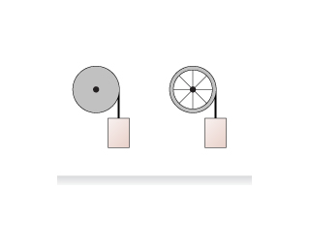
A
B
Which hits the ground first?
Block A hits the ground first.
Block B hits the ground first.
Block A and Block B hit at the same time.
Neither block ever hits the ground.
There is not enough information given.

3. (2 points) Two identical beakers are filled to the same height with water. Beaker B has a plastic sphere floating in it. Which beaker, with all its contents, weighs more?
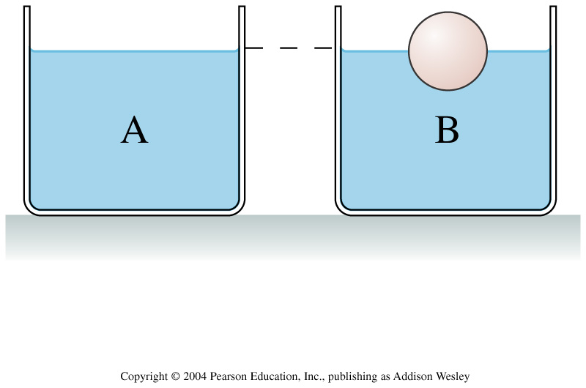 W_{a} < W_{b}
W_{a} > W_{b}
W_{a} = W_{b}
It depends upon the weight of the sphere.

4a. (2 points) A very strong gust of wind is just now blowing over the outside of your flat-roofed house. Which statement is most likely true:
P_{insidehouse} > P_{outsidehouse}
P_{insidehouse} < P_{outsidehouse}
P_{insidehouse} = P_{outsidehouse}

4b. (2 points) What is the net force on the roof it has a length of 3 meters a width of 5 meters and is 7 meters off the ground and the wind is blowing at 20 m/s? Take the density of air to be ρ=1.2kg/m³.
10

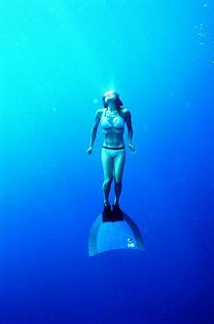5. (2 points) Free-divers are people who often go to deep depths without using a SCUBA tank or any other external air source. A free-diver takes a deep breath, jumps into the water, and then goes down 20 meters. To approximately what size does the free-diver’s lungs get compressed or expanded?

At 20 meters the free-diver’s lungs are roughly:
4 times their size at the surface
3 times their size at the surface
2 times their size at the surface
The same size as they were at the surface
½ the size they were at the surface
⅓ the size they were at the surface
¼ the size they were at the surface

6. The space shuttle orbits at an altitude of around 300km. The acceleration due to Earth’s gravity at this altitude produces an acceleration that is:
9.81m/s²
Slightly less than 9.81m/s²
Much less than 9.81m/s²
Slightly more than 9.81m/s²
Much more than 9.81m/s²
Zero
5. Four “T’s” are made from two identical rods of equal mass and length. Rank in order, from largest to smallest, the moments of inertia I_{a} to I_{d} for rotation about the dotted line.
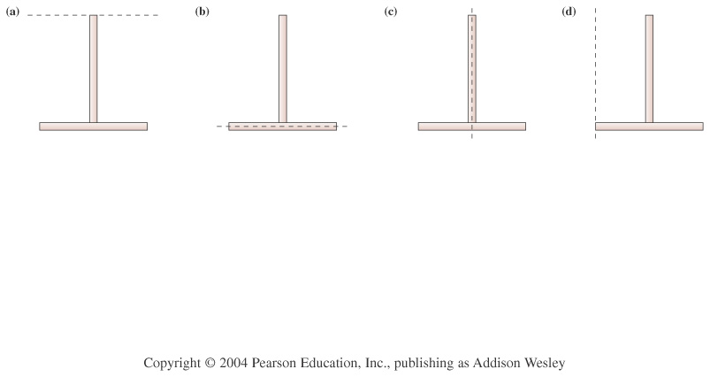
a b c d
6. The ruler in this picture is 1.0 meters long and has a mass of 35g. A 455g mass is placed 10.0 cm from the left side of the ruler. You pull up on the other side with a force of 8.0 N at an angle of 20° to the right of the vertical and 20.0cm for the right side.
8N
455g
What is the angular acceleration of the ruler about its center?

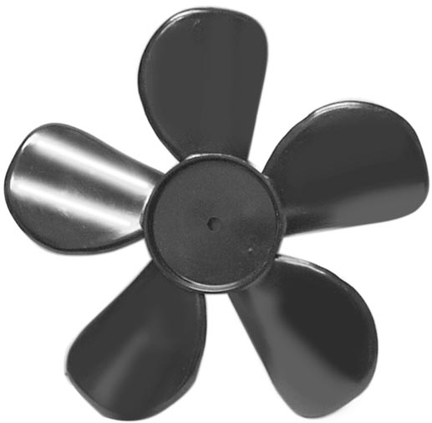
7. (2 points) The fan blade is slowing down and the torque points into the page. Which statement is true:
ω is currently positive.
ω is currently negative.
ω is currently zero.
it is not possible to know if ω is negative, positive or zero with the given information.
10

9. Taking the Earth’s rotation into account, how much more energy does it take to get 1kg of mass to escape the Earth from the equator compared to the energy needed to get that same 1kg of mass to escape the Earth if launched from the North Pole?

10
10.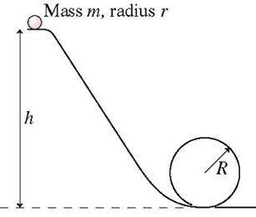 The marble rolls (without slipping) down a track and around a loop-the-loop of radius R. The marble has mass m and radius r. What minimum height h must the track have for the marble to make it around the loop-the-loop without falling off? State your final answer in terms of R, m, r, and g.

10
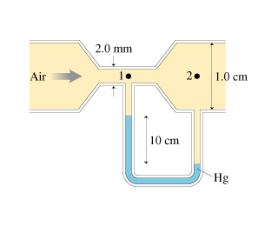9. (10 points) Air flows through the tube as shown. Mercury (ρ_{Hg} = 13.6g/cm³) is sitting in the connecting “U-Tube” as shown. Treating air (ρ_{air} = 1.2g/cm³) as an ideal fluid, answer the following questions:

- What is the air speed at point 1?

- What is the air speed at point 2?

- How many liters of air go through the pipe per second?

- You increase the quantity of air per unit time going through the pipe by a factor of two. What happens to the Mercury in the U-Tube?
The left side of the mercury moves up higher
The right side of the mercury moves up higher
Both sides move up higher.
The levels stay the same on both sides.
10

