HIP 8

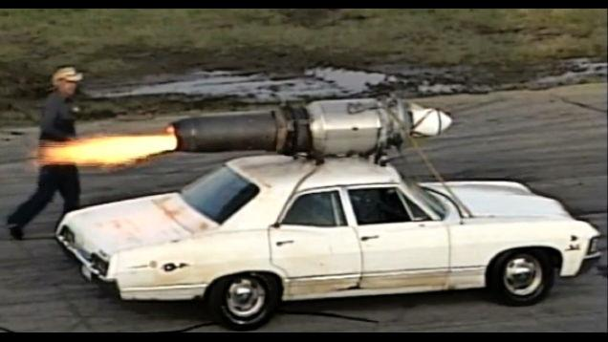
Paul Stender’s car has a rocket attached to it. While on, the rocket provides a thrust force of 51,500 Newtons. The car has as mass of 3,222kg. The coefficients of friction with the road and the tires are μ_{k}=.321, μ_{s}=.432, μ_{r}=.111, and the coefficient of drag is 0.800. The car is 3.0 meters long, 2.0 meters wide and 1.5 meters tall. The density of air is ρ=1.3kg/m³.

Remember that the equation for the force of drag is: D = ½ρAC_{d}v².

Create a program that keeps track of for every tenth of a second for the first 5 seconds…:
- …the amount of chemical energy burnt by the rocket
- …the amount of energy that is turned into thermal energy through wind drag
- …the amount of energy that is turned into thermal energy through rolling friction
- …The amount of energy that ends up as Kinetic Energy

You may assume a 100% efficient chemical process in the rocket. You may also assume that the mass change of the rocket is negligible.

As always, attach the normal scoring rubric and make sure that you complete all sections including the “problem setup” and “reasonableness” sections.

Chapter 10:
In the last chapter looked at the concept of work and began to use Conservation of Energy, which can be written as E_{before}=E_{after}, to solve problems. In this chapter, we get a lot more experience at using Conservation of Energy.

New equation introduced:
There aren’t any new equations introduced, but we used the concept of work from the last chapter to derive lots of equations. For example we can find and use: KE = ½mv²; U_{g} = mgh; U_{spring} = ½k(Δs)² and more.

Main Problem Solving Strategies Discussed -- we will add a possible short-cut to our standard “to do” list:
- Draw a picture!
- Set up a “good” coordinate system
- If you can use energy, you might get to skip d, e, f and g and go straight to deriving your energy equations. But, if you do need a FBD then…
- Make sure that you analyze each dimension
- Draw a FBD for every body in the problem.
- Create an equation using F_{net} = ma_{net} for every body in the problem. If the object is undergoing constant circular motion then F_{net} = F_{c}.
- Always check to see if you have constant accelerations or changing accelerations.

